Advance Cyber Security Serial No 09

Assignment 1

shreyyash

2020

March

Contents

1. Assignment 1: Date Command 3
   1. Introduction…………………………………………. 3
   2. Shell command txt file………………………………. 3
   3. Terminal output……………………………………... 4

List of figures

1.3 Date format terminal output………………………………. 4

CHAPTER 1

Assignment 1: Date Command

* 1. Introduction

The *date* command can be used in a variety of ways to check the dates and other parameters such as year, week, day and many more related to time.

* 1. Command

The following code snippet was run as a shell command to show the date in the desired format

*echo Date: $(date +"%D")*

*echo Time: $(date +"%T")*

*echo Zone: $(date +"%z")*

*echo ISO Week: $(date +"%V")*

*echo Week: $(date +"%u")*

*echo Weekday: $(date +"%A")*

*echo Month: $(date +"%B")*

1.3 The terminal output for the same is given below

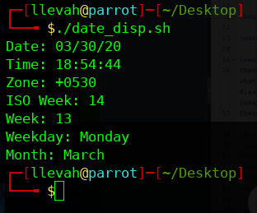

*Figure 1: Terminal output of date program*